Practical 7
7. For the given input values of x and y, compute coefficient values to build linear regression model and plot it. Use this model to predict the value of y for the new value of x. Also compute MSE and RSS. (Note: Use only numpy library)
import numpy as np
import matplotlib.pyplot as plt

# Given data
x = np.array([1, 2, 3, 4, 5])
y = np.array([2, 4, 8, 8, 10])

# Step 1: Calculate mean
x_mean = np.mean(x)
y_mean = np.mean(y)

# Step 2: Calculate slope (m) and intercept (c)
numerator = np.sum((x - x_mean) * (y - y_mean))
denominator = np.sum((x - x_mean)**2)

m = numerator / denominator
c = y_mean - m * x_mean

print("Slope (m):", m)
print("Intercept (c):", c)

# Step 3: Predicted y values
y_pred = m * x + c

# Step 4: Calculate MSE and RSS
mse = np.mean((y - y_pred)**2)
rss = np.sum((y - y_pred)**2)

print("MSE:", mse)
print("RSS:", rss)

# Step 5: Predict for new x value
x_new = 6
y_new = m * x_new + c
print("Predicted y for x = 6 :", y_new)

# Step 6: Plot
plt.scatter(x, y, label="Original Data")
plt.plot(x, y_pred, color='red', label="Regression Line")
plt.xlabel("X")
plt.ylabel("Y")

plt.show()

OUTPUT:
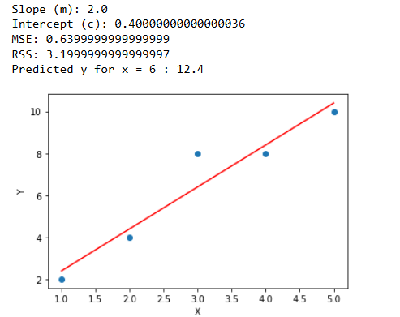

PRACTICAL-8
8. For the given input values of x and y, build a linear regression model using scipy library and plot it.

import numpy as np
import matplotlib.pyplot as plt
from scipy.stats import linregress

x = np.array([1,2,3,4,5,6,7,82,92,10])
y = np.array([2,31,52,55,55,12,23,33,33,22])

slope, intercept, r, p, std_err = linregress(x, y)

print("Slope:",slope)
print("Intercept:",intercept)
print("R-squared:",r**2)

# Plot
plt.scatter(x, y)
plt.plot(x, slope*x + intercept)
plt.xlabel("X")
plt.ylabel("Y")
plt.title("Simple Linear Regression")
plt.show()

OUTPUT:
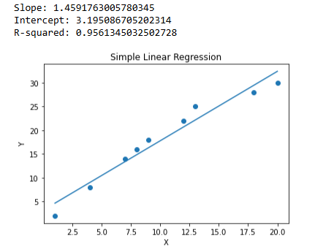

PRACTICAL9
9. Generate at least 100 random values of x and compute the corresponding y values with appropriate linear function. For these pairs of (X,Y), generate model using both of the above technique and compare them. Also find co-relation coefficient (R-value), Probability value (P-value), and standard error. Try to modify the values in (X, Y) and identify its effect on the R-value, P-value and standard error.

import numpy as np
import pandas as pd
import matplotlib.pyplot as plt
from scipy import stats
from sklearn.linear_model import LinearRegression

# Step 1: Generate random X
np.random.seed(42)
X = np.random.uniform(0, 50, 100)

# Step 2: Generate Y using linear function with noise
noise = np.random.normal(0, 10, 100)
Y = 3*X + 5 + noise

# Reshape for sklearn
X_reshaped = X.reshape(-1,1)

# METHOD 1: Using scipy
slope, intercept, r_value, p_value, std_err = stats.linregress(X, Y)

print("Method 1 (scipy)")
print("Slope:", slope)
print("Intercept:", intercept)
print("R-value:", r_value)
print("P-value:", p_value)
print("Standard Error:", std_err)

# METHOD 2: Using sklearn
model = LinearRegression()
model.fit(X_reshaped, Y)

print("\nMethod 2 (sklearn)")
print("Slope:", model.coef_[0])
print("Intercept:", model.intercept_)
# Plotting
# Create prediction line
X_sorted = np.sort(X)
X_sorted_reshaped = X_sorted.reshape(-1,1)
Y_pred = model.predict(X_sorted_reshaped)
plt.figure(figsize=(10,6))
# Scatter plot of original data
plt.scatter(X, Y, color='blue', alpha=0.6, label='Data points')
# Regression line
plt.plot(X_sorted, Y_pred, color='red', linewidth=2, label='Regression line')
# Labels and title
plt.xlabel("X")
plt.ylabel("Y")
plt.title("100 points random")

plt.show()

OUTPUT:
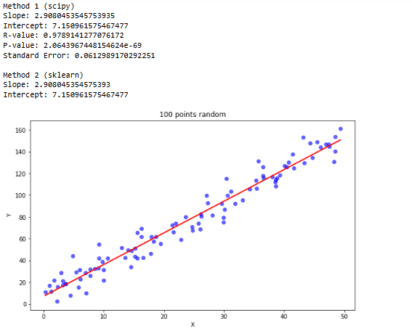

PRACTICAL10
10. Build a linear regression model that predicts house prices based on square footage.
import numpy as np
import matplotlib.pyplot as plt
from scipy.stats import linregress

x = np.array([500, 800, 1000, 1200, 1500, 1800, 2000, 2200])
y = np.array([100, 150, 200, 230, 300, 350, 400, 420])

# Build linear regression model
slope, intercept, r, p, std_err = linregress(sqft, price)

print("R-value:", r)
print("P-value:", p)

# Prediction for new house (example: 1600 sqft)
new_x = 1600
predicted_y = slope * new_x + intercept
print("Predicted price for 1600 sqft house:", predicted_y)

# Plot
plt.scatter(x, price, label="Actual Prices")
plt.plot(x, slope * x + intercept, color='red', label="Regression Line")
plt.xlabel("Square Footage")
plt.ylabel("House Price ($1000s)")
plt.title("House Price Prediction using Linear Regression")

plt.show()
OUTPUT:
